AMRITA VIDHYA VISHWAPEETHAM UNIVERSITY

DEPARTMENT OF AIE

SEM: V YEAR: III SUBCODE:19CSE202

ASSIGNMENT NO: 02

**Question : 01**

Query all columns for all American cities in the **CITY** table with populations larger than 100000. The **CountryCode** for America is USA.

The **CITY** table is described as follows:

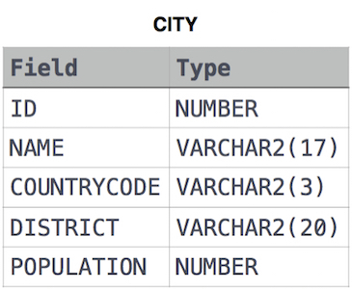

Question : 02

Query the **NAME** field for all American cities in the **CITY** table with populations larger than 120000. The CountryCode for America is USA.

The **CITY** table is described as follows:  


Question : 03

Query all columns (attributes) for every row in the **CITY** table.

The **CITY** table is described as follows:  


Question: 04

Query all columns for a city in **CITY** with the ID 1661.

The **CITY** table is described as follows:  


Question : 05

Query all attributes of every Japanese city in the **CITY** table. The **COUNTRYCODE** for Japan is JPN.

The **CITY** table is described as follows:  


Question : 06

Query the names of all the Japanese cities in the **CITY** table. The **COUNTRYCODE** for Japan is JPN.  
The **CITY** table is described as follows:  


Question : 07

Query a list of **CITY** and **STATE** from the **STATION** table.  
The **STATION** table is described as follows:  
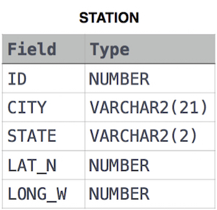

where **LAT_N** is the northern latitude and **LONG_W** is the western longitude.

Question : 08

Query a list of **CITY** names from **STATION** for cities that have an even **ID** number. Print the results in any order, but exclude duplicates from the answer.  
The **STATION** table is described as follows:



where **LAT_N** is the northern latitude and **LONG_W** is the western longitude.

Question : 09

Find the difference between the total number of **CITY** entries in the table and the number of distinct **CITY** entries in the table.  
The **STATION** table is described as follows:



where **LAT_N** is the northern latitude and **LONG_W** is the western longitude.

For example, if there are three records in the table with **CITY** values 'New York', 'New York', 'Bengalaru', there are 2 different city names: 'New York' and 'Bengalaru'. The query returns , because

Total number of records - number of unique city names = 3-2 =1

Question :10

Query the list of CITY names starting with vowels (i.e., a, e, i, o, or u) from **STATION**. Your result cannot contain duplicates.

**Input Format**

The **STATION** table is described as follows:



Question : 10

Query the two cities in **STATION** with the shortest and longest *CITY* names, as well as their respective lengths (i.e.: number of characters in the name). If there is more than one smallest or largest city, choose the one that comes first when ordered alphabetically.  
The **STATION** table is described as follows:



where **LAT_N** is the northern latitude and **LONG_W** is the western longitude.

**Sample Input**

For example, **CITY** has four entries: **DEF, ABC, PQRS** and **WXY**.

**Sample Output**

ABC 3

PQRS 4

**Explanation**

When ordered alphabetically, the **CITY** names are listed as **ABC, DEF, PQRS,** and **WXY**, with lengths  and . The longest name is **PQRS**, but there are  options for shortest named city. Choose **ABC**, because it comes first alphabetically.